SCHEDULING ALGORITHM

HARIRAJ G

230701104

FIRST COME FIRST SERVE (FCFS) Scheduling

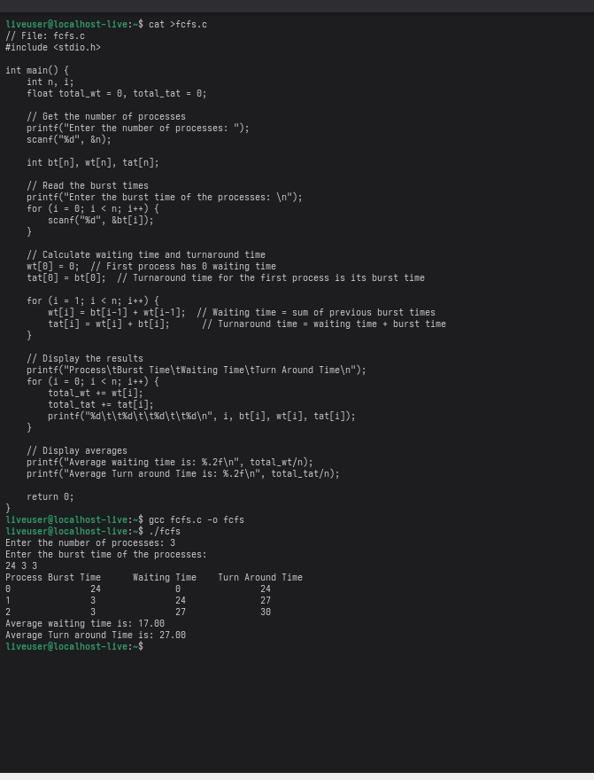

SHORTEST JOB FIRST (SJF) Scheduling

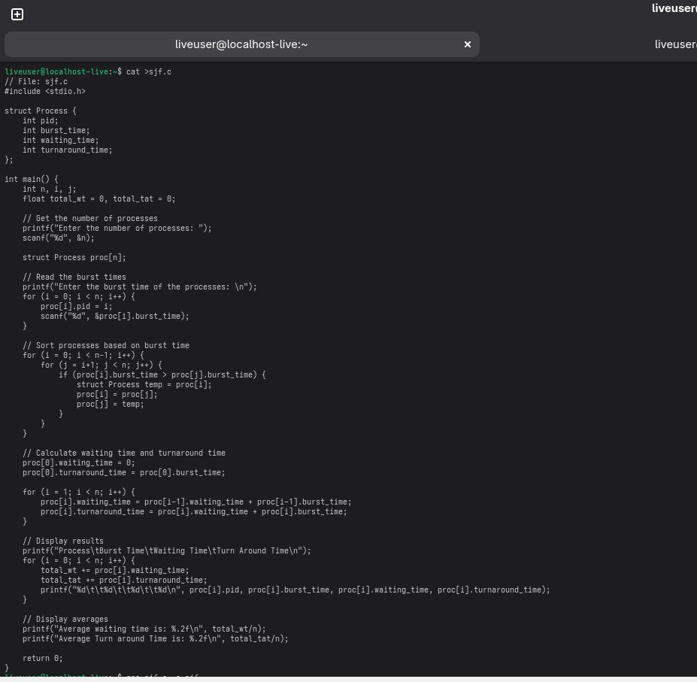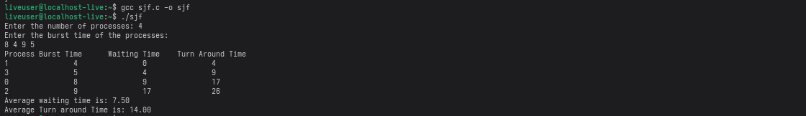

PRIORITY Scheduling

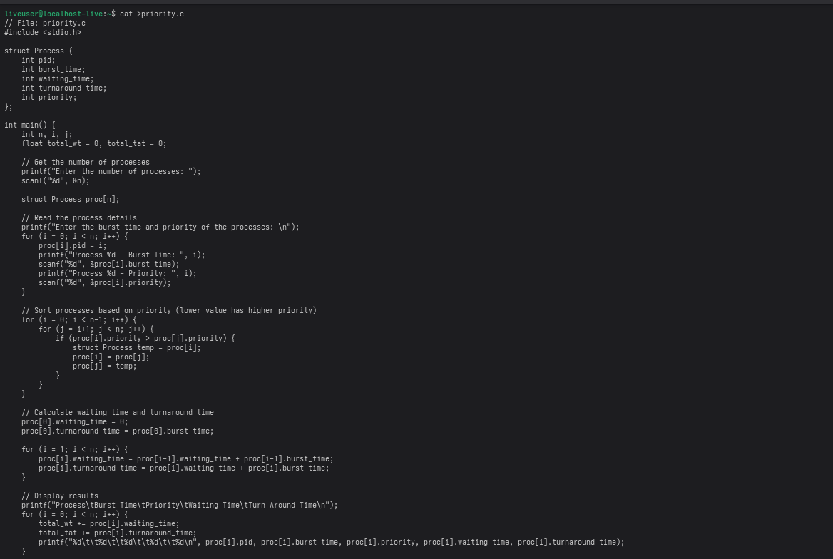

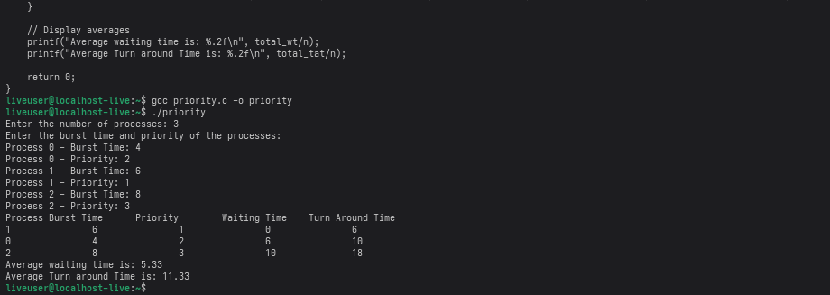

ROUND ROBIN (RR) Scheduling

